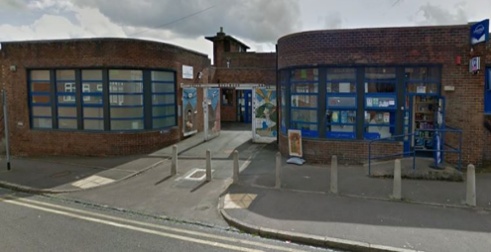**Practice Update**

***Summer 2022***

**Lucie Wedgwood**

**Surgery**

Welcome to our summer newsletter. Where has the time gone? We have already been blessed with some wonderful summer days but, as always, we need to remember that is can be difficult too, for many of us. Please stay hydrated and limit your time in direct sunlight.

**During the months of April, May and June 2022, we offered *2746* GP appointments, on average over *915 appointments* each month. We offered *2953* nurse and healthcare appointments, on average over *984*  appointments each month.**

This newsletter is for you, our patients. If there is anything you would like to see featured in these pages please let the reception team know and look out for it in future issues.

Hello & welcome to our Patient Participation Group (PPG).

We are a small group of patients who meet monthly at the surgery. We are passionate about the running of the surgery & we want to listen to patients and try to improve the services offered at the surgery. We all come with a wealth of experience from various backgrounds & our aim is to promote a good working relationship with the G.Ps & all the practice staff. We all want to promote good working practice in our surgery.

You will meet PPG members at our FLU clinics & COVID clinics. We take this opportunity to do a short survey with our patients where we ask the patients views of the surgery & any changes the patients would like to see done.

The results of the surveys are passed to the G.Ps & relevant staff. If you would like more information about our PPG please ask our reception.

We are always looking for new members & you may be the next patient to join us.

A few of our current PPG members below.

Sue (PPG Chair) Martin (PPG Member) Linda (PPG Member) Shaun (PPG Member)

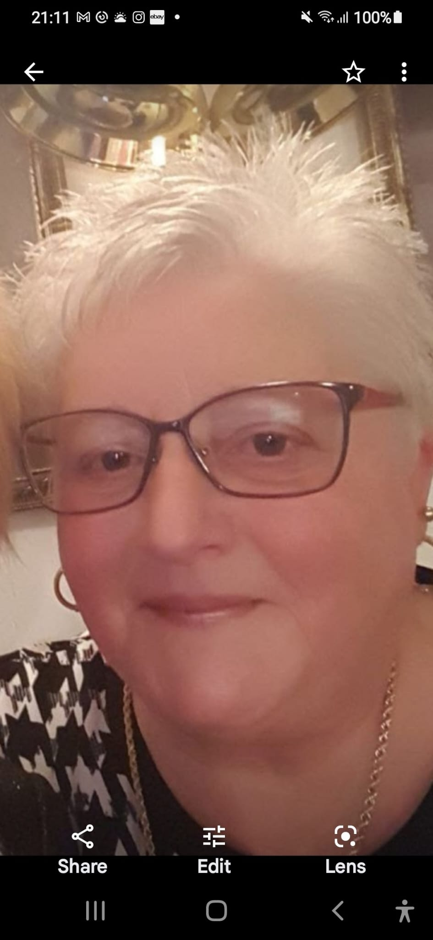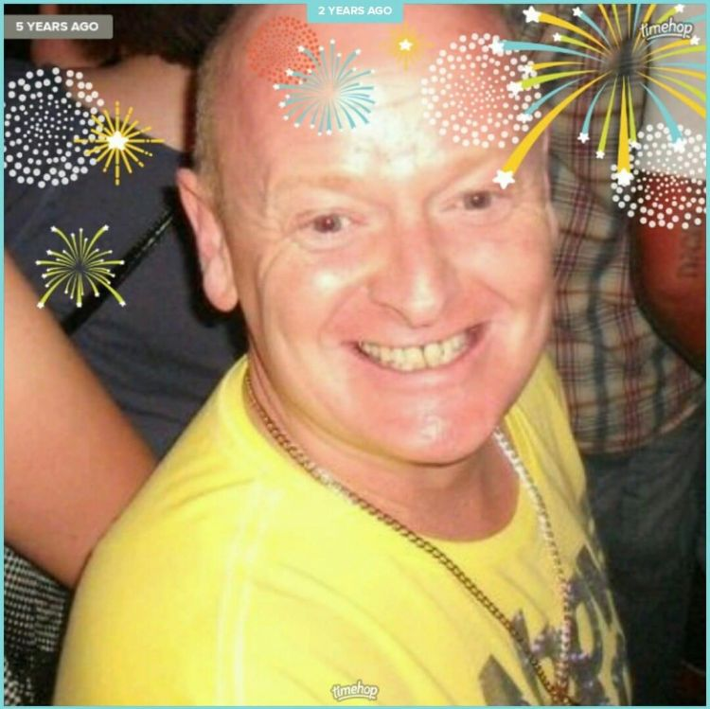 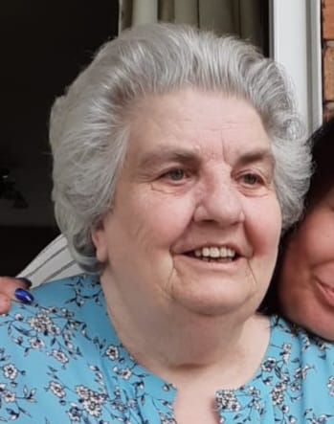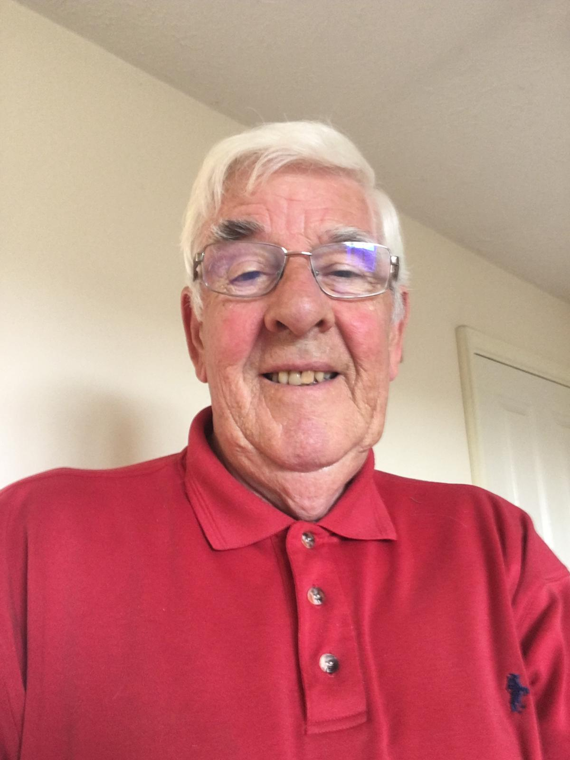

**Patient Participation Group**

**Preventing Diabetes**

Diabetes causes around 500 premature deaths in the UK each week. If you’ve never thought about your risk of type 2 diabetes, the NHS has a risk calculator that can help you to work out whether changes to your lifestyle may be needed.  
More than half of all cases of type 2 diabetes could be prevented or delayed, so making simple lifestyle changes now could improve your long term health.  
  
If lifestyle changes could help you to reduce your risk, some of the most effective changes you can make to help reduce your risk of type 2 diabetes are very simple. Please follow the links below for guidance.

[**https://riskscore.diabetes.org.uk/start**](https://riskscore.diabetes.org.uk/start)[**https://www.diabetes.org.uk/preventing-type-2-diabetes/can-diabetes-be-prevented**](https://www.diabetes.org.uk/preventing-type-2-diabetes/can-diabetes-be-prevented)

Lucie Wedgwood Surgery requests support in our campaign to help disadvantaged families in the Burslem area.

As a practice we would like to help our young parents to support their children. Our team would like to donate to parents of children in the 0-5 age category a “Wellness Pack”. Hopefully in receiving this Wellness Pack parents of young children are encouraged to attend routine immunisation appointments for their children and themselves, as well as help them to be more aware of how they can influence their children’s physical and mental wellbeing. Within the Wellness Pack we would like to include books, activity packs, toothbrush & toothpaste, small packs of creams and self-care reliefs, literature on self-care, also possibly a small gift voucher - to be used in local stores.

We would be so very grateful if you could support our practice by contributing to our campaign. Your contribution will go towards purchasing items in our Wellness Pack. If you are unable to donate financially but would like to contribute something we can add to our Wellness Pack, this would also be very much appreciated.

The full campaign letter can be viewed on our website. [**https://www.luciewedgwoodsurgery.nhs.uk/wellness-campaign-letter**](https://www.luciewedgwoodsurgery.nhs.uk/wellness-campaign-letter)

As the weather has been unseasonably warm, many of us have been spending more time outdoors than we normally would. We need to make sure we’re taking care of ourselves by applying the right amount of sun cream and drinking enough water. Many of us don’t apply enough sun cream to get full protection; you need more than you might think! Dehydration can have an impact on your health and if you’re feeling thirsty, you’re already dehydrated. While the recommendation is to drink 8 glasses of water per day, if the weather is very hot, or you’re exercising, you may find that you need to drink more than this to stay hydrated.  
When heatwaves are forecast, it’s even more important to be observant about the weather conditions and your physical well-being. You might also need to check on vulnerable family members and neighbours more frequently.

In the UK, there’s an alert system that tells you what you need to look out for.  
[**https://www.nhs.uk/live-well/healthy-body/heatwave-how-to-cope-in-hot-weather/**](https://www.nhs.uk/live-well/healthy-body/heatwave-how-to-cope-in-hot-weather/)

**Armed Forces**

**Wellness campaign**

**VETERAN FRIENDLY ACCREDITED GP PRACTICE**

We have recently been recognised as an Armed Forces veteran friendly accredited GP Practice. This means that as part of the health commitments of the Armed Forces Covenant, we have a dedicated clinician who has a specialist knowledge of military related health conditions. If you are ex-forces, please let us know so we can ensure you are receiving the best possible care from the surgery.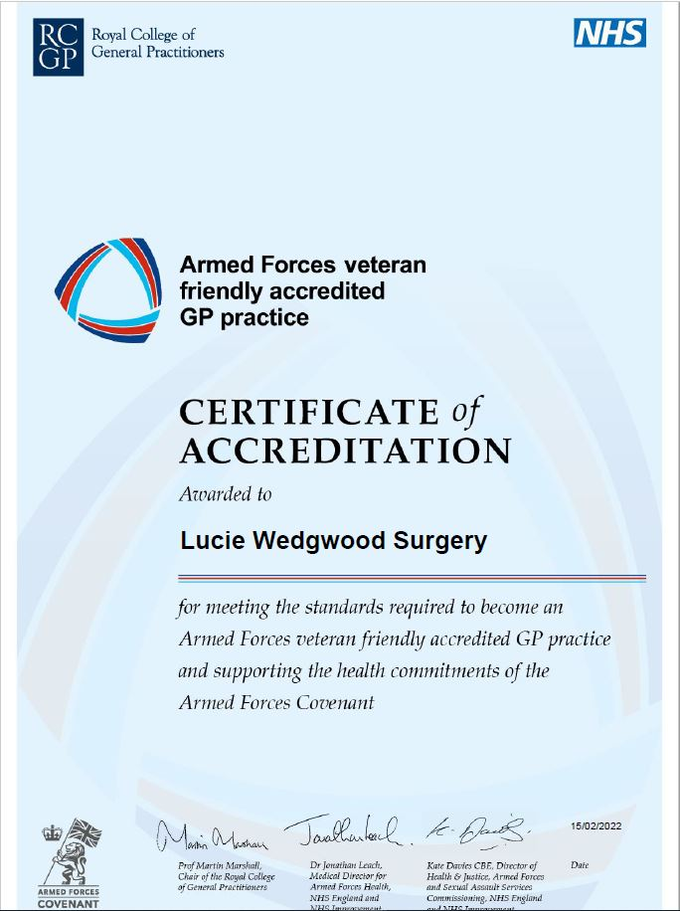

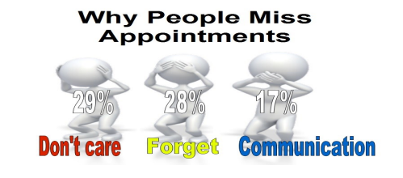

**During the month of April, May and June we had 32 GP missed appointments and 99 Nurse and Healthcare missed appointments.**

The practice does review all patients who do not attend their appointments. Where there is continued non-attendance of appointments, following a warning letter, the practice is entitled to remove patients from its practice list at this time. With increasing pressure on GP services we ask that if you can’t make your appointment, you cancel it. The appointment is then offered to someone who needs to be seen.

Please bear with us as we continue to make changes to the front reception area as well as our admin and reception team rooms. On arrival please note reception is on the right hand side, temporarily. We hope to have all work completed before the end of this year.

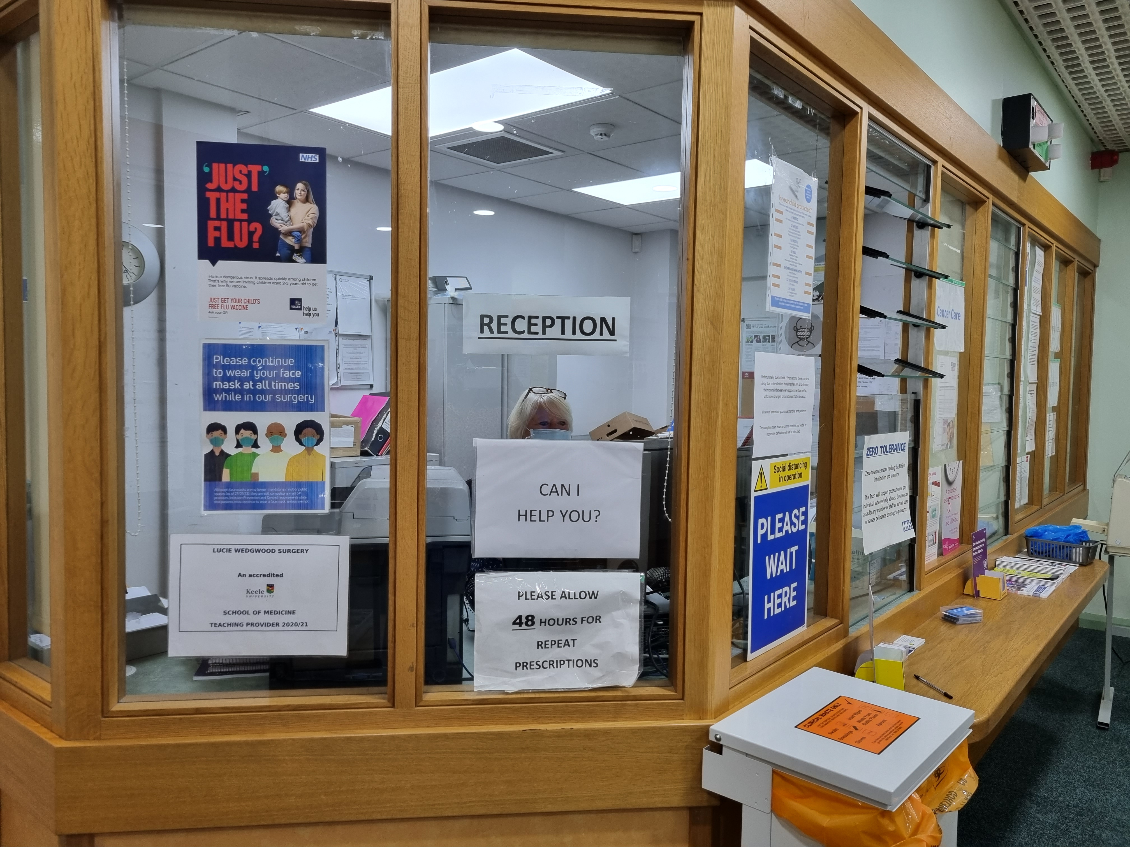

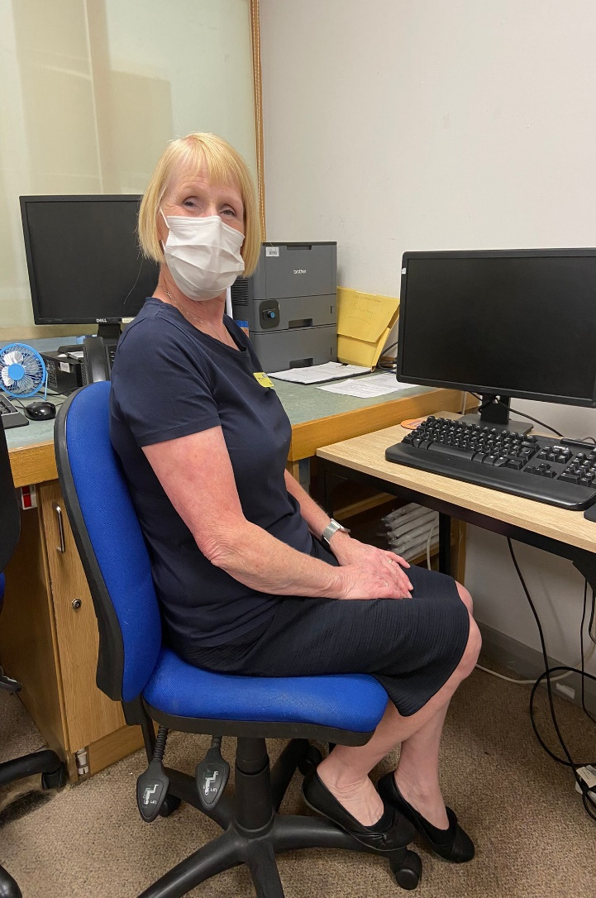

**Team Member Introduction - Mary**

I am married to Charlie and we have 2 Sons and 7 Grandchildren. I am in my early sixties.

I have worked for the NHS since I was 19 Years old. I initially started working at the hospital as an Auxiliary/Healthcare.

When I was 40 years old I started working in general practice at Chesterton Surgery and later moved to Kidsgrove Surgery.

I came to Lucie Wedgwood last year just on a temporary basis and after a few weeks they offered me a position. I felt at home here straight away and everyone was so friendly and helpful. I am sure I will stay here until I retire.