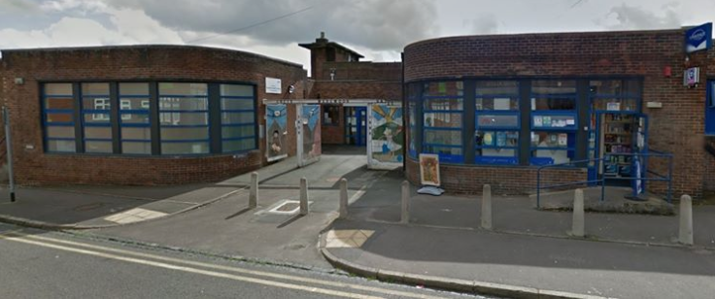
SPRING 2022
Lucie Wedgwood
Surgery

Practice Update
2021 has been a challenging year for us all, but here at Lucie Wedgwood Surgery we are proud of all we, and indeed, the wider NHS, have achieved.

- During the three months of January , February and March 2022, we offered 2777 GP
appointments, that’s on average over 926 appointments each month!
- During the same three month period, we offered 4066 Nurse appointments, on average
over 1355 appointments each month.
- We also ran multiple flu vaccination clinics and once again supported the National Covid19 Vaccination. Programme by running clinics at the surgery and offering walk-in vaccination.
Looking further afield, 2021 saw GP practices in England book more appointments than ever before, with an unprecedented 367 million appointments.

NEW FLOORING: During March and April all our carpeted clinical rooms and the hallway had new vinyl flooring laid. This is to improve Infection Prevention and Control (IPC) within the surgery. Our apologies for any inconvenience caused to patients and visitors to the surgery, during this period. We are very pleased with the new flooring and we hope our patients are as well.
Lucie Wedgwood Staff

PPG
In the last year the surgery has seen staff retire, move to other positions within the NHS, leave to pursue other ambitions and new staff join the team.
We said goodbye to Practice Nurse, Carrie; Medical Secretary, Jan and Administrator, Katelyn. We also said goodbye to Diana (Nurse/Practice Manager) as she retired after 25 years with Lucie Wedgwood Surgery.

We welcomed new team members, Amanda, Gillian, Mary, Kate and Aliya working in Reception and Administration.
Hannah, as a new Healthcare Assistant and Lisa, into the role of both Healthcare Assistant as well as her existing role as Receptionist. Our Lead Receptionist, Lorraine, is also training to become a G.Ps Assistant (GPA).

We also welcomed new Nurse/Practice Manager Sarah (also known as Sal) to take over Diana’s dual role.
Lucie Wedgwood Surgery Patient Participation Group (PPG) are looking to recruit new members. If you are interested in joining the PPG please inform staff at the reception or complete the online form on the practice website: link below.
https://www.luciewedgwoodsurgery.nhs.uk/patient-group/join-ppg/
Mrs Susan Finney is the chair for the PPG.
The PPG have welcomed Susan Fulcher as a new member to their group.
During the last PPG meeting a new noticeboard area was assigned for their use, to inform patients of the work they are currently focusing on.
Also at the last meeting, information regarding research with Keele University on accessibility for patients was discussed.

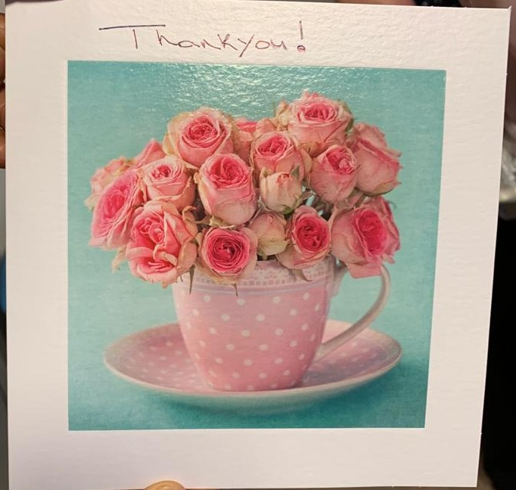
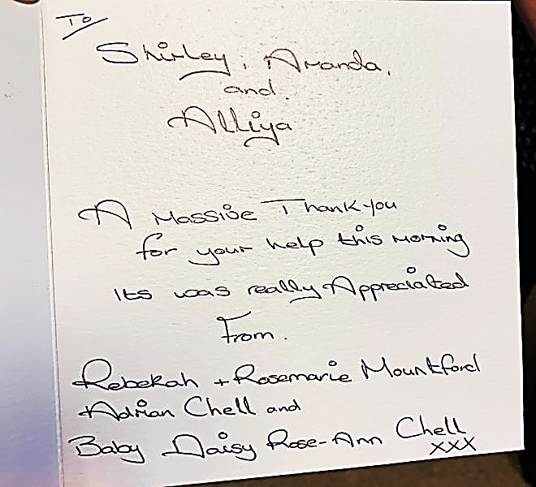
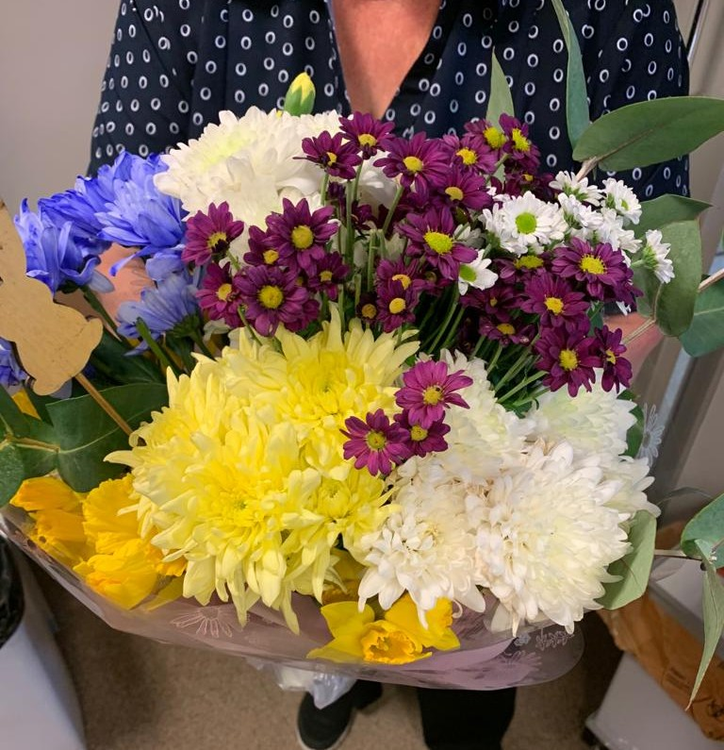

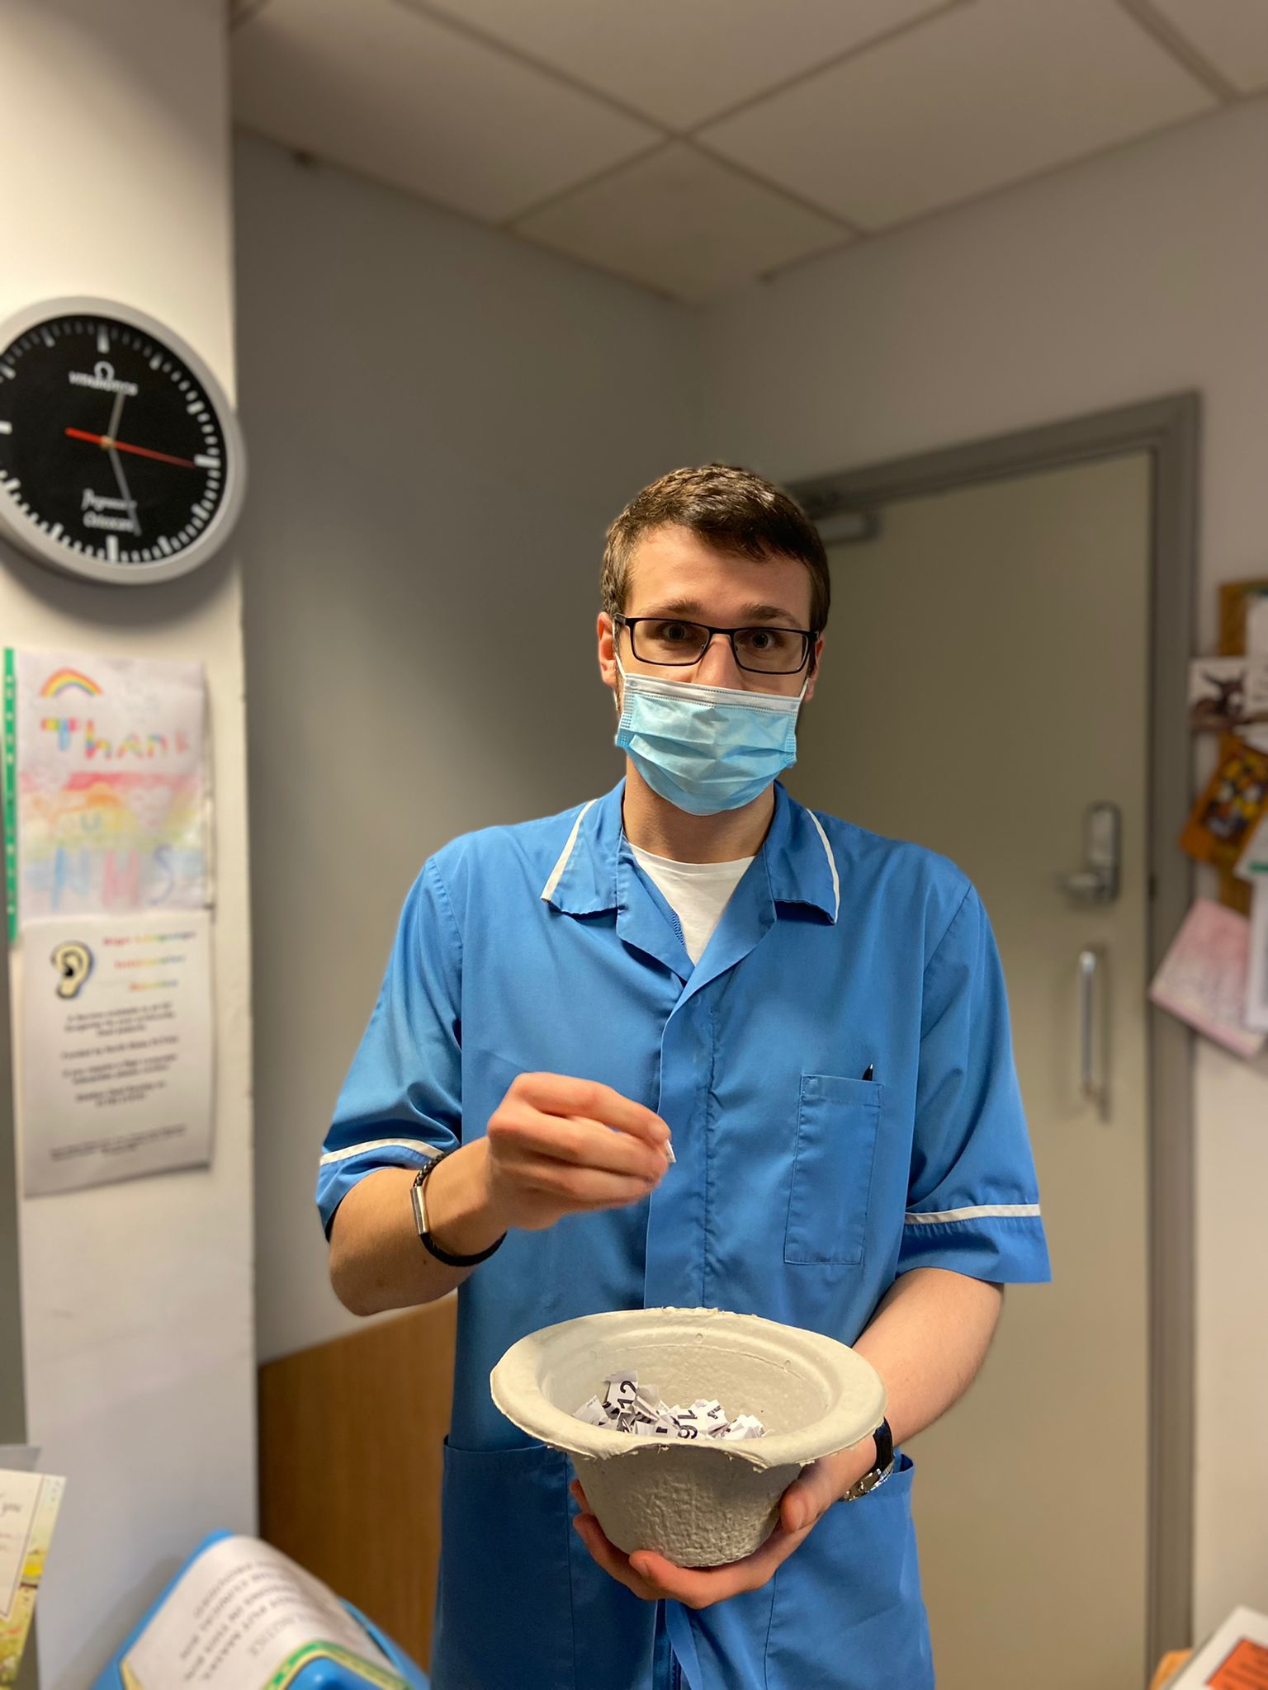
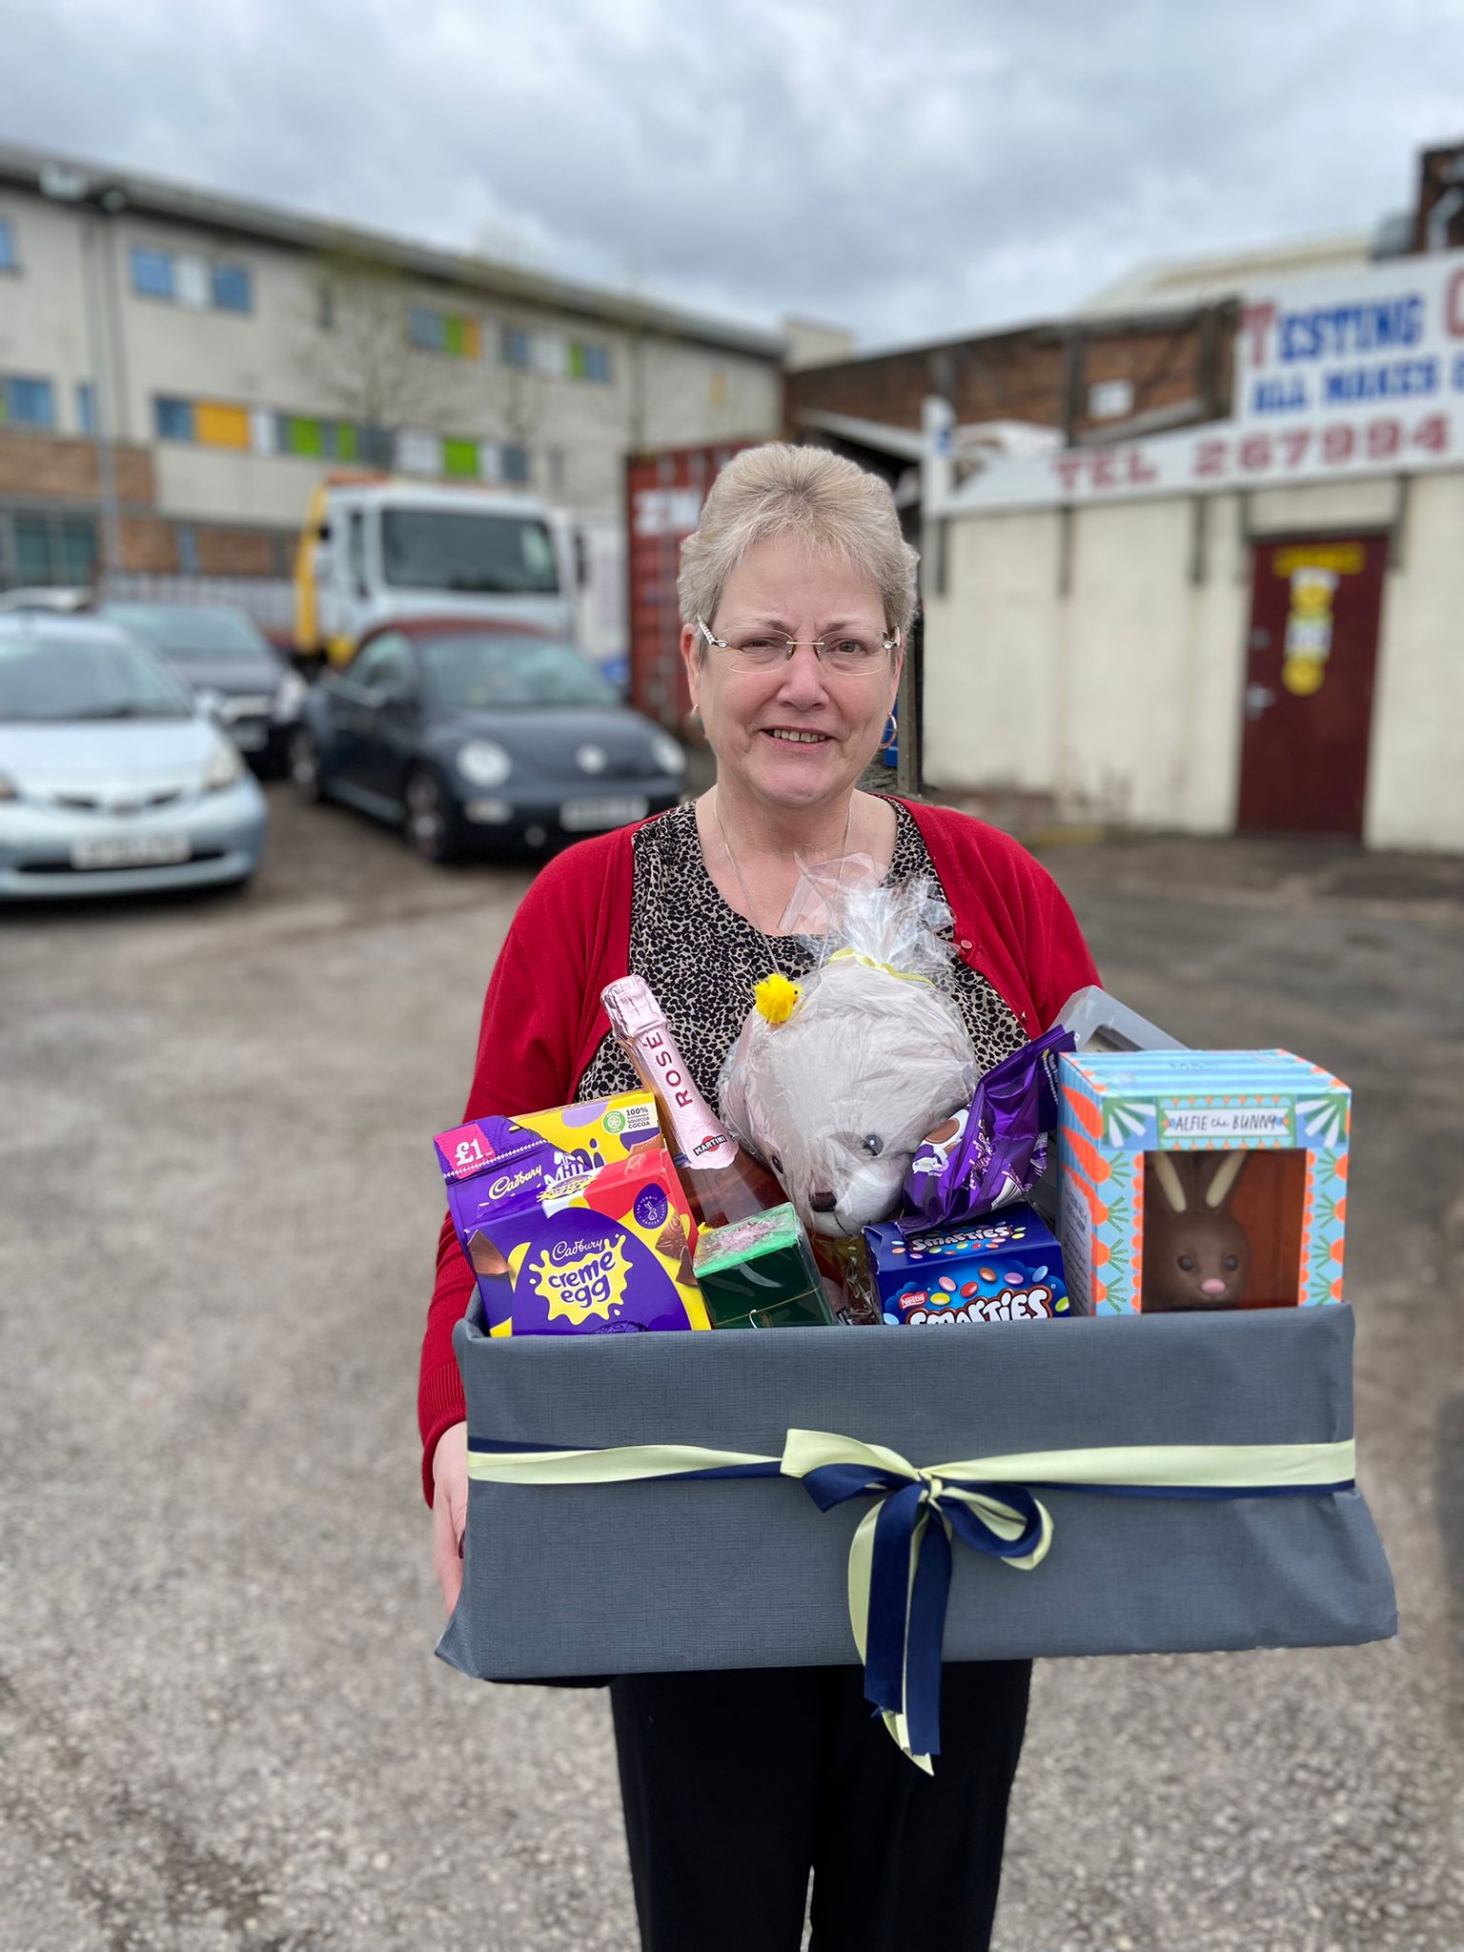

Easter Raffle
Thank you
Walk-in Chest X-Ray Service
Deaf Awareness in May.
Lucie Wedgwood Surgery raised funds for the Ukrainian crisis appeal by selling raffle tickets to win our Easter hamper; put together by the staff and patients.
The surgery managed to raise £105.00. This was sent to Ukrainian refugee children, to begin lifesaving NHS cancer care.
The draw was carried out by Bret from Burslem pharmacy. The winning number was 205.
Congratulations to Sheila!
Thank you to everyone who supported.

During the week of 4-9 May 2022, it is deaf awareness week. The aim of Deaf Awareness Week is to raise awareness of hearing loss in the UK and its impact on people's lives. Because deafness is not a visible condition, deaf and hard of hearing individuals can feel misunderstood, unseen, invisible and isolated.
During this Deaf awareness week the UK council on deafness are focusing on Inclusion Deafness, to explore the entire theme of inclusion within our community. They will highlight the impact of hearing loss on everyday life and increase visibility and inclusion of Deaf people. They will emphasise importance of mental health in Deaf, and empathise with underrepresented groups amongst Deaf such as migrants, BMIs, and women, as well as raise relevant issues of deafness being overlooked in education, health settings and the workplace.

From Monday 11th April 2022 the Imaging Department at UHNM are re-commencing a GP walk-in service for Chest X-ray Requests Only at the sites and times detailed below.
Haywood Hospital
High Lane, Burslem, Stoke – On – Trent
ST6 7AG
Tel: (01782) 673666
Chest Direct Access Opening Times:
Mon – Fri 4:00pm – 7:00pm
Sat – Sun 9:00am – 3:30pm
Cobridge Health Centre
Church Terrace, Cobridge,
Stoke – On - Trent.
ST6 2JN
Tel: (0300) 790 0164
Chest Direct Access Opening Times:
Mon – Fri: 8:30am – 12:00 noon
Leek Moorlands Hospital
Ashbourne Road,
Leek. Staffordshire.
ST13 5BQ
Tel: (0300) 123 1894
Chest Direct Access Opening Times:
Mon, Wed, Thurs. 1:30pm – 4:45pm
County Hospital
Weston Road,
Stafford. Staffordshire.
ST16 3SA
Tel: 01785 230153
Chest Direct Access Opening Times:
Mon – Fri: 1:00pm – 4:00pm
For further information please contact the UHNM Imaging Help Desk 01782
679285
Easter Raffle
Beautiful flowers and a lovely card received by the reception team, from a thankful patient.
All at Lucie Wedgwood Surgery are very grateful for the recognition received for our hard working reception team.
Thank you!
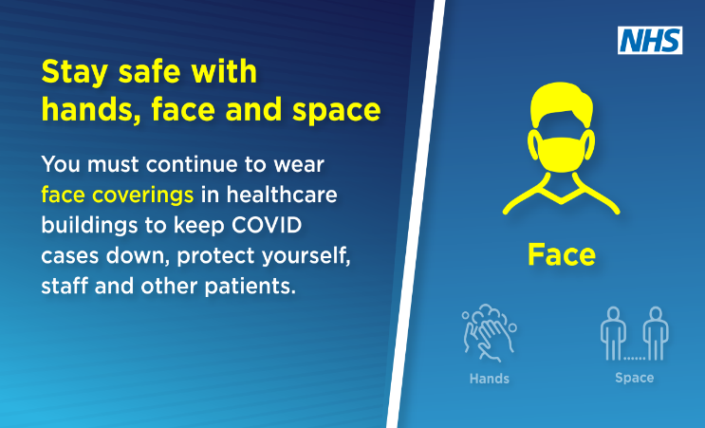
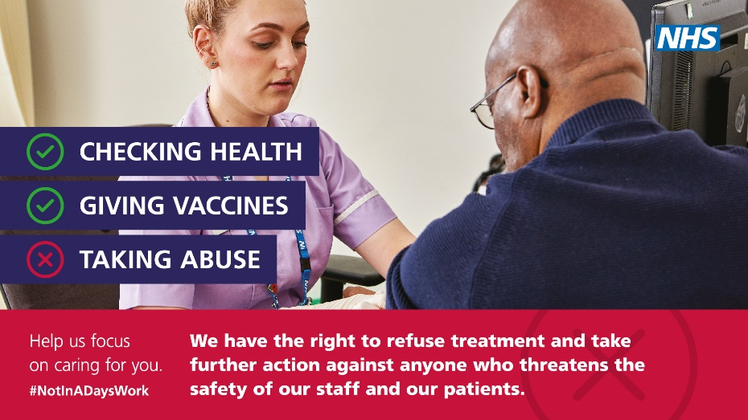
Team Member Introduction - Sarah Barlow
PRESCRIPTION REQUEST AND COLLECTION
The practice turnaround time for prescriptions whether the request is a paper prescription or an electronic one is
48 hours (not including weekends or bank holidays)
THE SURGERY DOES NOT ACCEPT TELEPHONE REQUESTS FOR MEDICATION.
You can request your repeat medication in the following ways: Completing the side slip; leaving a note at
reception detailing your medication; using our on-line repeat request system, or signing up with a local
Pharmacy repeat medication management service.
Thank you for your assistance

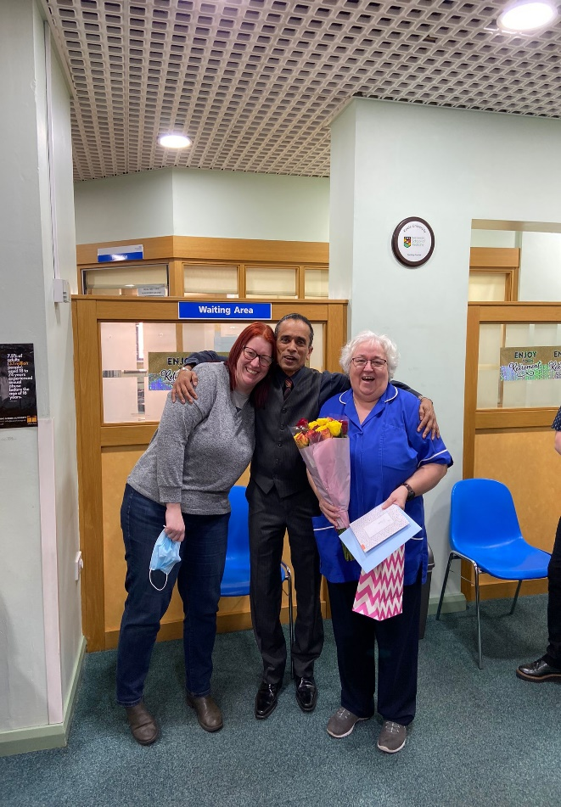

I am in my mid 40’s, married to Stephen, we have 6 children between us and live in the Newcastle area.
I qualified as a Nurse in February 2009 and started my first Nursing role in North Staffs A&E. After 1 year, I was offered an opportunity to work in a GP surgery in Butt Lane, as a practice Nurse. I worked for 5 years doing both jobs. After leaving A&E and Butt Lane Surgery I went to work at Hanley Walk in Centre and then at Apsley Surgery for 5 years, before working a short time at Brinsley Avenue Surgery. In 2019, I started to work within the 6 surgeries at Loomer Medical Practice where I stayed throughout the Pandemic until finally moving to Lucie Wedgwood Surgery, for which I have now made my forever home.
As soon as I walked in Lucie Wedgwood Surgery, I instantly had the feeling I was home. I have loved every minute of my time at Lucie Wedgwood so far, the staff and all the patients are so lovely and look forward to working with you all over the next 20+ years.

