Lucie Wedgwood Surgery Ltd

CHAPEL LANE,
BURSLEM,
STOKE-ON-TRENT,
STAFFORDSHIRE,
ST6 2AB
TEL: 01782 834488
EMAIL: Burslemhealth.centre@nhs.net

Dr A.B.Surendran
Dr N. Narhlya
Dr M.Varathodiyil

Contents
Social | Page 3-8
Mental Health | Page 9-10
Chronic Diseases | Page 11-12
General Health | Page 13-17
Elderly care/ Carers | Page 18-21
Where to get help – if unwell | Page 22-26
Contraception and Sexual health | Page 27-30
Emergency Dentist | Page 31
Acute Eye Service | Page 32
Care Teams/District Nurses | Page 33-35
Occupational Therapy | Page 36-37
Wheelchair and Equipment services | Page 38
Help with finances | Page 39
Citizens advice bureau | Page 40
Conclusion | Page 41

Social
Keeping active and involved in your local community can have a positive impact upon your health and wellbeing. Community based activities can help you to learn new skills, keep active, meet people, make a difference in your community and have fun.

What types of activities can I join?
Due to COVID-19 many activities have been restricted and temporarily stopped but there are now opportunities to join
- Social groups such as friendship groups, women's groups, older peoples clubs.
- Sports and leisure activities such as walking, swimming and other exercise, fishing, gardening, arts and drama groups.
How do I find out about local activities and groups?
- In person at local libraries, sports centres, community halls, health centres, council offices, churches and other places of worship.
- Reading local newspapers, magazines and listening to your local radio station.
- Speaking with your health visitor, home carer, social work staff or health professional.
- Chatting to your neighbours, friends and family
- Online (if you cannot access online services you could ask a friend or relative to look for you)– you can visit ageuk.org, the Staffordshire connect website, social media platforms. These are all really good sources to find out what’s on in the local community.

Age UK
What activities do Ageing Well run?
Due to COVID-19 the following activities are running again following government guidelines to keep everybody safe.

- Gentle Exercise – these sessions last 1-2 hours including time for refreshments. There is a £3 charge however it is a fantastic opportunity to make new friends, gain confidence and to keep active. This helps to improve your balance and co-ordination.
- Walking Groups – ageing well takes walks in parks, canal paths and any open space across north Staffordshire – they can be 1, 3 or 5 mile walks. This aims to improve your mobility.
- Practical Health and safety talks – this will help to improve your knowledge on healthy eating, preventing falls, reducing blood pressure, being safe in your own home and while out and about.

These activities are open to anyone aged 50 and over in the Stoke-on-Trent area.

So, what are the benefits?
Older people can benefit from:
- Increased energy levels
- Promoting good mental health and keeping your mind active
- Helping with weight control
- Improved sleep
- Reducing the risks of falling, heart disease, strokes, raised cholesterol, stress, arthritis and osteoporosis
- Gaining confidence and self-esteem
- Meeting new people and making new friend

Contact
If you would like to contact ageing well, be a volunteer or have any questions please call;
01782 200739
Or email
info@ageukstaffordshire.org.uk
PLEASE BE AWARE THIS IS JUST AN EXAMPLE OF THE ACTIVITIES, PLEASE CALL STAFFORDSHIRE AGE UK FOR AN UP TO DATE SCHEDULE OR VISIT THERE WEBSITE https://www.ageuk.org.uk/

Staffordshire Connect

It’s now easier than ever to find what you need.

Staffordshire connect is a website that helps you to search for organizations, groups, activities, clubs, services, online support and communities that can help you to live independently and well. You can also type in any word in the search box, adding in your postcode and using the filters to narrow down your search.
Please note: Due to the Coronavirus, some groups, services and activities may have changed how they operate. Please check websites, ring, email or contact the service via social media if you would like to find out what support is available.

Please visit the Staffordshire connect website on; https://www.staffordshireconnects.info

If you do not have access to a computer or mobile please ask a neighbor, friend or relative.

Below are the services that Staffordshire connect offer for adults. Each one offers numerous drop downs in each category.

Social Prescriber
A free, confidential and supportive social prescribing service offered face to face or over the telephone to help you to gain improved health and wellbeing. Support is offered in a way that suits the individual and their needs and can be formal or informal. To get in touch with a social prescriber please contact the GP surgery.

How does it work?
Any social worker, GP or health professional in North Staffs & Stoke can make a referral. An appointment is made with the social prescriber who can discuss any issues affecting the person’s health or wellbeing. They will help to access support services and to work towards positive solutions.

How is help provided?
The social prescriber will listen and support with any decisions the individual feels will help and provide information and guidance on what is available and how to access it. They will help to identify areas that the individual is ready to work on and offer information guidance and support to make the necessary changes to improve health and wellbeing. They can do weekly telephone calls and put you in touch with groups that you think will be beneficial.

Example of support they can help to access;
- Bereavement, depression and/or anxiety support and counselling;
- Befriending Services – practical advice and support for people who have long term conditions but who have become very socially isolated and therefore at risk of their health deteriorating. They help to increase opportunities to socialise and to retain independence in your own home;
- Local social activities e.g. lunch clubs/friendship groups/activities;
- Support services to help you to manage Long Term Conditions .e.g COPD/MS/Parkinsons/Stroke;
- Services supporting vulnerable people e.g. refugees, offenders;
- Help and support for homelessness/risk of becoming homeless;
- Alcohol & Substance Misuse Support;
- Support for people with physical or learning disabilities;
- Organisation’s helping with mental health difficulties;
- Housing advice and support, help with tenancies;
- Debt management, money management and financial and benefits advice;
- Practical housing services – including heating, rent & repairs, shopping, cleaning.
Benefits from support received include:
- Improved fitness
- Learning new skills
- Increased mobility
- Managing depression
- Reduction in levels of anxiety
- Reduced isolation & loneliness

Mental Health
Physical and Mental Wellbeing
The Mind and Body are inseparable and our physical health is very important for our overall sense of wellbeing. Our mental health can be affected by our physical health and vice versa and this is why it is vital that you take care of both!
What is Physical Wellbeing?
Physical Wellbeing relates to your general level of physical fitness, i.e. cardio-respiratory endurance, muscular strength, flexibility etc – plus related factors such as: adequate nutrition, proper weight management, avoidance of drug or alcohol abuse, sexual responsibility, general hygiene and adequate sleep.
What is Mental Wellbeing?
Feeling well is not just about being physically fit and healthy – it’s equally important to your overall health that you feel good mentally. Although the two can be linked together, there are several things that you can do to help keep a sense of mental wellbeing. You could try and make arrangements to meet up with family and friends, perhaps engage in a new hobby or try and get involved with activities within your local community. Spending time with other people can prevent you from feeling lonely or anxious and give you a chance to share experiences, thoughts and any worries that you may have.
There are organisations set up locally that can help with your Mental Wellbeing and the details are as below.
- Staffordshire and Stoke-on-Trent wellbeing service – 0800 032 8728 – website: www.staffsandstokewellbeing.nhs.uk
- MIND - 01782 262100, email: reception@nsmind.org.uk, website: http://www.nsmind.org.uk/
- 24-hour mental health helpline - 01782 234233.
- Changes – 01782 413101, email: stoke@changes.org.uk, website: http://www.changes.org.uk/
- North Staffordshire Combined Healthcare – A telephone helpline offering support 24 hours a day, seven days a week for people who are concerned about their own mental health or somebody else’s. - 0300 123 0907 (OPTION 1), website: https://www.combined.nhs.uk/how-to-access-us-in-a-crisis/ - If you have a hearing impairment and are unable to utilize the telephone, you can text the service on 07739 775202 and the team will respond as soon as possible (please note: this text service is charged at your network provider’s rate).
- The Dove Service - offer a 'Dove Buddies' group, every Tuesday 10.30-11.30am where residents can register to join a social/friendship group to combat loneliness and social isolation. They also offer an alleviating isolation group every Wednesday 1.30-2.3pm. This group was created to support those who supporting others as they struggle with the impact of grief and loss during Covid-19 - 01782 683155, email; enquiries@thedoveservice.org.uk

- If you are concerned about an immediate risk of harm – either to yourself or someone else – then phone 999.

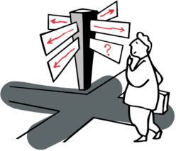

Chronic Diseases
If you are suffering with a Chronic Disease such as Asthma, Diabetes, COPD etc or have social issues that you may be worried about and would like to talk to somebody on a confidential basis, you can contact your GP or speak with a Practice Nurse or if you feel uncomfortable about this in any way then please see below a list of Helplines that you may find useful.

- Heart Disease

British Heart Foundation (Heart Matters Helpline) Tel: 0300 330 3311.
If you are worried about anything heart related, give them a call and they can discuss with you your heart condition, medication, a healthy diet, offer support groups and discuss how to lower your risk factors such as high blood pressure etc.

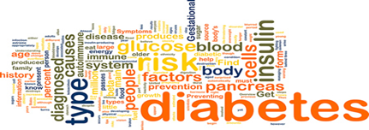
- Diabetes

The Diabetes UK North Staffordshire Voluntary Group’s overall aim is to help and to care for people with Diabetes, and those who care for them. The Service is open to all those affected by Diabetes and those who are interested in the condition. They aim to educate diabetics of all ages to minimise the effect of this disease and to become independent and knowledgeable about their own condition.
You can telephone the North Staffordshire Voluntary Group on (01782) 861690, email: office@diabetesuknorthstaffs.org, website: https://www.diabetesuknorthstaffs.org/
They are based at Bradwell Lodge, Bradwell Lane, Porthill, Newcastle-under-Lyme. Staffordshire. ST5 8PS.

- Asthma and COPD
The Breath Easy Support Group Network (North Staffordshire) provides support and information for people living with a lung condition, and for those who look after them. Breathe Easy Groups are run by members, with help and support from the British Lung Foundation regional teams.
You can telephone the British Lung Foundation on: 03000 030 555
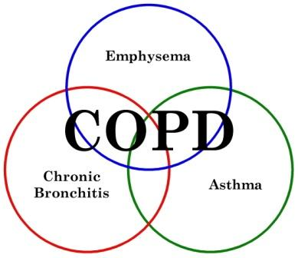

- Asthma UK
Every ten seconds someone in the UK has a potentially life-threatening asthma attack and three people die every day. Tragically two thirds of these deaths could be prevented, whilst others still suffer with asthma so severe current treatments don't work.
This has to change. That's why Asthma UK exists. They work to stop asthma attacks and, ultimately, cure asthma by funding world leading research and scientists, campaigning for change and supporting people with asthma to reduce their risk of a potentially life threatening asthma attack.
All their booklets, leaflets and written asthma action plans have been developed alongside healthcare professionals who have a specialist interest in asthma and people with asthma who know what it’s like to live with the condition. Certified by The Information Standard, they’re designed to help you manage your asthma well. You can download them, or order print copies on 0300 222 5800 (Mon - Fri; 9am-5pm).
Alternatively, you can make an appointment with a Practice Nurse at the surgery who will monitor your condition and advice on further management.

Drug and alcohol
- The Community Drug and Alcohol Service – Provides support to people struggling with drug and alcohol addiction. Website: https://www.scdas.org.uk/ Telephone: 01782 283113
- Rehab 4 Addiction - A helpline assisting those affected by substance misuse for people who are concerned about their own or a loved one's drug and alcohol addiction. Website: https://www.rehab4addiction.co.uk/ Telephone: 0800 140 4690
- Drinkline - Drinkline is the national alcohol helpline. If you're worried about your own or someone else's drinking, you can call this free helpline in complete confidence. Call 0300 123 1110 (weekdays 9am to 8pm, weekends 11am to 4pm).

Gambling
- Gamcare – GamCare provides confidential counselling, advice and information for anyone affected by a gambling dependency. Telephone: 0808 8020 133 (free from mobiles). GambleAware® aims to promote responsibility in gambling. They provide information to help people make informed decisions about their gambling. They help you to find out more about gambling and what responsible gambling means, to understand and recognize problem gambling, and show you where to go for further information, help and support should you need it. For most people, gambling is a fun, recreational activity which they are able to enjoy without losing control. However for some people gambling can become a serious problem, both for themselves and for their family, friends, and those concerned about them.

Smoking

Smoking causes around 90% of lung cancers and is also linked to cancer in other parts of the body, heart disease, lung disease and other serious conditions. Over 80% of cigarette smoke is invisible and odorless, so no matter how careful you think you’re being, your family still breathes in more harmful chemicals than you think. This puts your children at risk of serious illness including glue ear, cancer, bronchitis and pneumonia.
If you smoke, quitting is one of the best things you'll ever do for your health. As soon as you stop smoking you'll see the benefits to your everyday life, health and wallet. And your family will thank you for it, too.
You'll be surprised at how quickly you see the benefits once you stub out that last cigarette. Your breathing and general fitness will improve, your skin will look better and your sense of taste will return. And that's just the start.
Your family mean the world to you and secondhand smoke is harmful to them, especially children. The best way to protect your loved ones is to quit smoking. This will reduce their risk of asthma attacks, ear infections and cancers.
Quitting smoking is not only good for your health, it is really good for your wallet. Smoking is expensive and it all adds up. On average, most people who quit save around £250 each month. What else could you spend that money on?
There are lots of ways to quit, from using nicotine replacement therapies or e-cigarettes, to free quit tools and expert support from local NHS stop smoking services. You can put together a package that fits into your lifestyle.
What are you waiting for? You can quit today!
If you would like to quit smoking or want any more information on the programs available please visit https://www.nhs.uk/live-well/quit-smoking/nhs-stop-smoking-services-help-you-quit/ or https://www.stoke.gov.uk/site/xfp/scripts/xforms_form.php?formID=78&language=en
If you do not have access to the internet please call the free Smokefree National helpline on 0300 123 1044

Diet
Eating a balanced diet
A diet based on starchy foods such as potatoes, bread, rice and pasta; with plenty of fruit and vegetables; some protein-rich foods such as meat, fish and lentils; some milk and dairy foods; and not too much fat, salt or sugar, will give you all the nutrients you need.
When it comes to a healthy diet, balance is the key to getting it right. This means eating a wide variety of foods in the right proportions, and consuming the right amount of food and drink to achieve and maintain a healthy body weight.
Most adults in England are overweight or obese. That means many of us are eating more than we need, and should eat less. And it's not just food: some drinks can also be high in calories.
Guideline daily amounts are derived from Government dietary recommendations for the UK population. They provide a guide to how many calories and nutrients we can consume each day for a healthy balanced diet.

Guideline Daily Amount
Guideline Daily Amounts (GDAs) are a nutritional facts label that originally began in 1998 as a collaboration between the UK government, the food industry and consumer organizations. The process was overseen by the Institute of Grocery Distribution (IGD). To help consumers make sense of the nutrition information provided on food labels, they translate science into consumer friendly information, providing guidelines on pack that help consumers put the nutrition information they read on a food label into the context of their overall diet.
Example of a label:
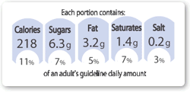

GDAs are guidelines for healthy adults and children about the approximate amount of calories, fat, saturated fat, total sugars, and sodium/salt. The GDA labels have the percentage of daily value per serving and the absolute amount per serving of these categories.

Guideline Daily Amount Values
Typical values | Women | Men | Children (5-10 years)
Calories | 2,000 kcal | 2,500 kcal | 1,800 kcal
Protein | 45 g | 55 g | 24 g
Carbohydrate | 230 g | 300g | 220 g
Sugars | 90 g | 120 g | 85 g
Fat | 70 g | 95 g | 70 g
Saturates | 20 g | 30 g | 20 g
Fibre | 24 g | 24 g | 15 g
Salt | 6 g | 6 g | 4 g

Eating too much of these nutrients when you are already at high risk for high blood pressure, high cholesterol and high blood glucose, could further increase risk of heart disease, stroke, diabetes and even some cancers. Using GDAs as a guide to how much energy and key nutrients are required for a healthy diet and following them on the long term could even help reduce overall risk of these unwanted conditions.
Those who take part in extensive activity, those who are not active at all, pregnant and breast feeding mothers and those on a special diet for whatever reason, will need to seek more particular nutrition advice for their needs.
If you have any specific queries or concerns about your diet it is advised you speak to your doctor, practice nurse or registered dietitian as they will be able to give you individual advice and guide you in the right direction.

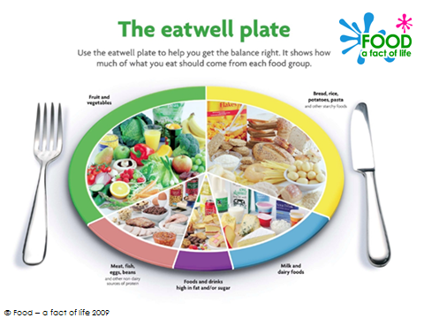

Food groups in our diet

The eatwell plate shows that to have a healthy, balanced diet, people should try to eat:
- plenty of fruit and vegetables
- plenty of starchy foods, such as bread, rice, potatoes and pasta
- some meat, fish, eggs, beans and other non-dairy sources of protein
- some milk and dairy foods
- just a small amount of food and drinks that are high in fat and/or sugar.
Try to choose a variety of different foods from the four main food groups.
Most people in the UK eat and drink too many calories, too much fat, sugar and salt, and not enough fruit, vegetables, oily fish and fibre. It is important to have some fat in your diet. The eatwell plate does not have to apply to every meal. Balance can be achieved over a day or several days. The eatwell plate is for everyone OVER 2 years of age.
If you would like more information about healthy eating, losing weight or about maintaining a healthy lifestyle you can contact your GP Surgery and make an appointment with a Practice Nurse or a Healthcare Support Worker who will be able to advise you further or alternatively you can contact NHS Choices.

Elderly Care
Age UK North Staffordshire is a local registered Charity and has worked since 1991 to promote the well-being of older people living in Stoke-on-Trent, Newcastle-under-Lyme and Staffordshire Moorlands, and to help make later life a fulfilling and enjoyable experience. They provide information and advice on all issues affecting people aged 50 and over, and their families and carers.
They have a range of booklets which can be provided to you on a range of topics including the following:-
- Caring At Home Getting Help to live independently in your own home)
- Managing Your Money (Practical tips for keeping costs down)
- Healthy Living (Maintaining a healthy body and mind)
- Staying Steady (Keep active and reduce your risk of falling)
- Adapting Your Home (Services and equipment to help you stay living at home)
- Staying Safe (Personal security at home and when you are out and about)
- Caring with someone with Dementia ( A practical guide to help you)
- More money in your pocket (A guide to claiming benefits)
- Wills and estate planning (Practical advice about making and updating a will)
- Staying cool in a heatwave (Tips to keep you cool when it is very hot)
You can visit these booklets online at https://www.ageuk.org.uk/services/information-advice/guides-and-factsheets/ alternatively you can order printed copies of any guides or factsheets by calling 0800 678 1602. Lines are open 8am-7pm 365 days a year.

You can contact Age UK Staffordshire on 01785 788499

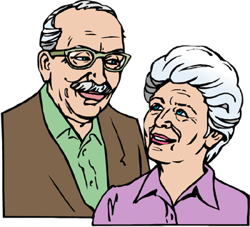

Services for Older People
Approximately 4,000 people aged 65 and over locally will be experiencing long-tern loneliness. Loneliness is an issue which can affect people of all ages and backgrounds. Loneliness is a bigger problem than simply an emotional experience. Research shows that loneliness and social isolation are as harmful to our health as smoking 15 cigarettes a day, and more damaging than obesity. Loneliness also increases our risk of disability and dementia.
- What you can do to help - Keep in touch with people in your family or neighbourhood that might be lonely. Make time to make a phone call or a visit, or to just stop and chat. Find out about local services and activities that can help someone who might be lonely to connect with others and get involved in their community, and pass on information it that is appropriate.
- What can you do if you’re feeling lonely:
- Think about what you would like more of – maybe time with friends or family, if so, invite them to visit. Often people will respond to an invitation and come and share quality time with you.
- Look after yourself – small steps to eat well, take gentle exercise and keep active can help you to relax more fully in your own company.
- Share your skills and time – by helping out in your neighbourhood or with local organisations, including those that work with older people.
- Get involved in local activities – find out what is available and join up. Saltbox (Tel: 01782 810320), delivers services which support vulnerable people, provide befriending and professional emotional support for older and vulnerable people and support older people to participate and engage. They also deal with financial issues, volunteering opportunities and offer one-to-one support.
- Speak to someone – Talk to a Health Worker if you feel very lonely – long term loneliness can affect your health. Your GP should be able to direct you to local services. You can also call The Silver Line helpline on (Freephone) 0800 474 8090 for information, advice or just a chat, 24 hours a day, 7 days a week.
- The Dove Service - offer a 'Dove Buddies' group, every Tuesday 10.30-11.30am where residents can register to join a social/friendship group to combat loneliness and social isolation. They also offer an alleviating isolation group every Wednesday 1.30-2.3pm. This group was created to support those who supporting others as they struggle with the impact of grief and loss during Covid-19. Telephone: 01782 683155.

- The Royal Voluntary Services - who support thousands of older people every day to stay independent in their own homes and enrich their lives. Whether it's Meals on Wheels, Good Neighbours or their home library services, they can offer the practical help that can make all the difference. The Good Neighbours and befriending services not only provide much-needed social contact for older people, they also contribute to hospital avoidance, a major social good. Please telephone 01782 917938 or 0330 555 0310 or visit their website on www.royalvoluntaryservice.org.uk for more information.

Carers
It can be a very worrying time if you are thinking about caring for someone who is coming out of hospital and who can no longer care for themselves in the same way as before.
Deciding to care or continue caring for someone who is coming out of hospital and who can no longer care for themselves in the same way as before can be very difficult.
You may not have considered yourself a carer until now and so will need to come to terms with a completely new situation – perhaps, for example, bringing home an older relative who used to live alone. Or you may have been caring for someone at home but are now unsure whether you can provide the extra care they will need after their hospital stay.

What is a Carer?
A carer is anyone who cares, unpaid, for a friend or family member who due to illness, disability, a mental health problem or an addiction cannot cope without their support.
Each carer’s experience is unique to their own circumstances.
The causes of someone taking on caring responsibilities are varied but can include:
- Serious physical illness
- Long-term physical disability
- Long-term neurological conditions
- Mental health problems
- Dementia
- Addiction
- Learning difficulties

The duties of a carer
The reasons why someone becomes a carer can vary greatly, and the variety of tasks that a carer fulfils is diverse. There is not a minimum time requirement or age restriction that “qualifies” someone as being a carer. They can include the following duties:
- Practical household tasks such as cooking, cleaning, washing up, ironing, paying bills and financial management.
- Personal care such as bathing, dressing, lifting, administering medication and collecting prescriptions.
- Emotional support such as listening, offering advice and friendship.
Someone in their seventies who cares 24/7 for their spouse with severe dementia is a carer. A teenager who offers emotional support and helps to keep the household running as and when the fluctuating nature of their parent’s mental health requires it — is also a carer. The two situations are very different. Both are individual examples of the 7 million carers in the UK today.
If you are someone caring for a relative or friend and feel you would like to know more information about this please visit the website www.carers.uk.org. Alternatively, you can telephone The North Staffs Carers Association on 01782 793100. Their Address is: Carers Centre, Fern House, 1 Duke Street, Fenton, Stoke-on-Trent. Staffs. ST4 3NR.
The Carers Centre offers a warm friendly relaxing environment and is for Carers of all ages. It is a place for Carers to have that well-earned respite break. The Centre offers Carers the opportunity of knowing that there is somewhere they can visit whether it’s just for a cup of tea, some time out, to attend a support group, gain a new skill or to have a relaxing massage – the list is endless. The Carers File can be found readily available within your local GP Surgery. Please ask the Reception Staff on your next visit to the GP.

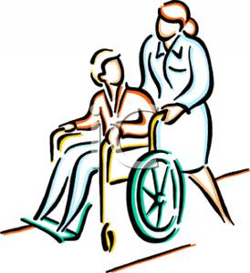

Where to get help – if unwell

Your Local GP Surgery
Please note that the Surgery Opening Times for Lucie Wedgwood Health Centre are as listed below:
MONDAY: | 7.00AM | 6.00PM
TUESDAY: | 7.30AM | 6.00PM
WEDNESDAY: | 7.30AM | 6.00PM
THURSDAY: | 7.30AM | 1.00PM
FRIDAY: | 7.00AM | 6.00PM

Your Local Pharmacist
Pharmacists offer professional free health advice at any time – you don’t need an appointment. From coughs and colds to aches and pains, they can give you expert help on everyday illnesses. They can answer questions about prescribed and over-the-counter medicines. Your local Pharmacist can also advise on healthy eating, obesity and help with giving up smoking. Some pharmacists have private areas where you can talk in confidence. They may suggest that you visit your GP for more serious symptoms. It is possible to purchase many medicines form the chemist without a prescription.
At present there are a few Chemists/Pharmacies within the local area who are currently operating a Minor Ailments Scheme. This scheme enables the patient who may be suffering with a short term medical problem which can be treated accordingly or advice given by a trained Pharmacist. There is a list of criteria/minor ailments which are held by the Pharmacy and includes ailments such as Mouth Ulcers, Bites and Stings, Flu and Cold like symptoms, Diarrhoea, Earache, and Cystitis etc. Please contact the Pharmacist for more information about the scheme.

There are 3 Pharmacies in the local area operating the scheme and they are:

 |  | OPENING TIMES
Waterloo Road Pharmacy | Monday | 8.30am | 11.59pm
Tel: 01782 827167 | Tuesday | 8.30am | 11.59pm
 | Wednesday | 8.30am | 11.59pm
 | Thursday | 8.30am | 11.59pm
 | Friday | 8.30am | 11.59pm
 | Saturday | 9.00am | 10.00pm
 | Sunday | 10.00am | 8.00pm
Burslem Pharmacy | Monday | 8.30am | 6.00pm
Tel: 01782 814197 | Tuesday | 8.30am | 6.00pm
 | Wednesday | 8.30am | 6.00pm
 | Thursday | 8.30am | 1.00pm
 | Friday | 8.30am | 6.00pm
 | Saturday | 9.00am | 1.00pm
 | Sunday | CLOSED
Queen Street Pharmacy | Monday | 9.00am | 5.30pm
Tel: 01782 839592 | Tuesday | 9.00am | 5.30pm
 | Wednesday | 9.00am | 5.30pm
 | Thursday | 9.00am | 5.30pm
 | Friday | 9.00am | 5.30pm
 | Saturday | 9.00am | 5.30pm
 | Sunday | CLOSED
cie wedgwood health centre
chapel lane
burslem, stoke on trent
ST6 2AB
Telephone: 01782 814197
Monday ➔ 08:30 - 13:00 & 14:00 - 18:00
Tuesday ➔ 08:30 - 13:00 & 14:00 - 19:00
Wednesday ➔ 08:30 - 13:00 & 14:00 - 18:00
Thursday ➔ 08:30 - 13:00
Friday ➔ 08:30 - 13:00 & 14:00 - 18:00
Saturday ➔ 09:00 - 13:00
Sunday ➔ Closed

lucie wedgwood health centre
chapel lane
burslem, stoke on trent
ST6 2AB
Telephone: 01782 814197
Monday ➔ 08:30 - 13:00 & 14:00 - 18:00
Tuesday ➔ 08:30 - 13:00 & 14:00 - 19:00
Wednesday ➔ 08:30 - 13:00 & 14:00 - 18:00
Thursday ➔ 08:30 - 13:00
Friday ➔ 08:30 - 13:00 & 14:00 - 18:00
Saturday ➔ 09:00 - 13:00
Sunday ➔ Closed

lucie wedgwood health centre
chapel lane
burslem, stoke on trent
ST6 2AB
Telephone: 01782 814197
Monday ➔ 08:30 - 13:00 & 14:00 - 18:00
Tuesday ➔ 08:30 - 13:00 & 14:00 - 19:00
Wednesday ➔ 08:30 - 13:00 & 14:00 - 18:00
Thursday ➔ 08:30 - 13:00
Friday ➔ 08:30 - 13:00 & 14:00 - 18:00
Saturday ➔ 09:00 - 13:00
Sunday ➔ Closed

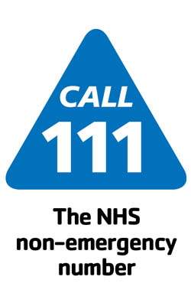
Emergency Out of Hours Service (111)
111 is the NHS non-emergency number. It’s fast, easy and free. Call 111 and speak to a highly trained adviser, supported by healthcare professionals. They will ask you a series of questions to assess your symptoms and immediately direct you to the best medical care for you. NHS 111 is available 24 hours a day, 365 days a year. Calls are free from landlines and mobile phones.

When to use 111
You should use the NHS 111 service if you urgently need medical help or advice but it's not a life-threatening situation.
Call 111 if:
- you need medical help fast but it's not a 999 emergency
- you think you need to go to A&E or need another NHS urgent care service
- you don't know who to call or you don't have a GP to call
- you need health information or reassurance about what to do next
For less urgent health needs, contact your GP or local pharmacist in the usual way.
If a health professional has given you a specific phone number to call when you are concerned about your condition, continue to use that number.
For immediate, life-threatening emergencies, continue to call 999.

How does it work?
The NHS 111 service is staffed by a team of fully trained advisers, supported by experienced nurses and paramedics. They will ask you questions to assess your symptoms, then give you the healthcare advice you need or direct you to the local service that can help you best. That could be A&E, an out-of-hours doctor, an urgent care centre or a walk-in-centre, a community nurse, an emergency dentist or a late-opening chemist.
Where possible, the NHS 111 team will book you an appointment or transfer you directly to the people you need to speak to. If NHS 111 advisers think you need an ambulance, they will immediately arrange for one to be sent to you.
Calls to 111 are recorded. All calls and the records created are maintained securely, and will only be shared with others directly involved with your care.

Haywood Walk-in-Centre
The Haywood Walk-in Centre is a nurse-led service which offers convenient access to a wide range of minor injury / minor ailment services. The department is open every day and no appointment is necessary.

What do they do?
A wide range of conditions can be treated including:
- Wounds, cuts and grazes, minor burns
- Rashes
- Ear infections
- Sprains and strains
- Suspected fractures
- Bites and stings
- Minor head injuries
- Foreign bodies in the eye.

Where we they based?
Haywood Hospital Walk-in Centre, Haywood Hospital, High Lane, Burslem, Stoke-on-Trent, ST6 7AG
Telephone: 01782 673500
We have on-site parking, including disabled parking. The Walk-in Centre is situated on the ground floor of the Haywood Hospital. Wheelchair access and disabled toilets are available.

How do you access the Haywood Walk in centre?
Patients with minor injuries or minor ailments may self-refer to the service. You should only attend A&E for serious and life-threatening conditions such as chest pain or breathing problems.

Hours of service
The services are operational between the hours of 7am-09:30pm Monday to Friday and 9am-09:30pm at weekends. *Please note Bank Holiday opening hours differ.

NHS Walk-In Centre at Hanley Health and Wellbeing

The Walk-in Centre at the Hanley Health and Wellbeing Centre can treat a range of minor illnesses and injuries without an appointment, 7 days a week. Telephone: 0300 123 6759

Who can use the walk-in centre and what can they do?
Anyone can use the walk-in service: you don’t need to be a registered patient with the centre.

It’s open 9am-5pm Monday- Friday. CLOSED weekends. You can find the walk in on 69/71 Stafford Street, Hanley, Stoke-on-Trent, Staffordshire, ST1 1LW

If you need medical assistance outside of opening hours you can call the out-of-hours service on 111.

What illnesses and injuries can be treated at the walk-in centre:
- cuts and grazes, minor scalds and burns
- strains and sprains
- bites and stings
- ear and throat infections
- minor skin infections and rashes
- minor eye conditions and infections
- stomach upsets
- coughs, colds and flu-like symptoms, and other minor common illnesses

They also provide: Emergency contraception, Chlamydia Screening, A Dressings Service

Please note that they cannot help with:
- serious medical emergencies posing an immediate threat to a person’s health or life
- road traffic accident injury
- serious head injury - loss of consciousness
- overdoses of drugs or accidental drinking of chemicals
- severe allergic reaction
- emergency care following an operation
If it is an emergency, you will need to go to your local accident and emergency (A&E) department. They also cannot provide doctor’s certificates or repeat prescriptions. For these you will need to make an appointment with your own GP
Emergency Contraception
Emergency contraception prevents pregnancy if:
- you haven't used contraception
- your usual method of contraception has failed
It depends what type of emergency contraception you use. There are two methods:
- the emergency contraceptive pill (morning after pill) – there are two types, Levonelle or EllaOne
- the intrauterine device (IUD, or coil)
Emergency contraception should not be used instead of your usual method of contraception. The sooner you use emergency contraception after having unprotected sex, the more effective it is.
- Levonelle
You can get Levonelle free of charge from:
- contraception clinics
- most sexual health clinics, also known as genitourinary medicine (GUM) clinics
- most NHS walk-in centres (England only)
- most GP surgeries
- some hospital accident and emergency (A&E) departments
Levonelle can be taken within 72 hours (three days) of having unprotected sex, but it's most effective if taken within 12 hours of having unprotected sex.
You take one Levonelle tablet. It works by stopping or delaying ovulation (when your ovaries release an egg).
- EllaOne
You can get EllaOne free of charge with a prescription from your GP. EllaOne is only recommended in women aged 18 or over because its safety and effectiveness have only been confirmed in women in that age group. EllaOne can be taken within 120 hours (five days) of having unprotected sex, but it's most effective if taken as soon as possible after having unprotected sex.
You take one EllaOne tablet. It stops or delays ovulation and makes it more difficult for a fertilized egg to implant into your womb.
If you're sick (vomit) within three hours of taking Levonelle or EllaOne, speak to your GP. You may need to take another pill.

CASH services (contraception and sexual health) and GUM services (testing and treatment for sexual transmitted infections including HIV)
Address:
Cobridge Community Health Centre
Church Terrace
Cobridge
Stoke-on-Trent
ST6 2JN
Telephone:
0300 790 0165
Opening times:
- Monday 08:30am-7pm
- Tuesday 08:30am-7pm
- Wednesday 08:30am-3:30pm
- Thursday 08:30-7pm
- Friday 08:30-1:30pm
- Saturday CLOSED
- Sunday CLOSED

You can call the national sexual health helpline free on 0300 123 7123. Your call will be treated with sensitivity and in strict confidence.

SH:24
SH:24 is sexual health 24/7. They provide free STI test kits and results within 7 days. Confidential testing, information and advice with discreet packaging.
Please visit their website: https://sh24.org.uk/
Alternatively please call them on 020 3318 7609

Other Services
- British Pregnancy Advisory Service (bpas) – provides advice and support about contraception, abortion and sexual health; call the helpline on 03457 30 40 30, open 24 hours a day, 7 days a week, or email info@bpas.org
- Switchboard: the LGBT+ helpline – provides an information, support and referral service for lesbians, gay men, bisexual and trans (transgender, transsexual, transvestite) people; call the helpline on 0300 330 0630, open 10am to 11pm daily
- Terrence Higgins Trust – provides information, support and advice about HIV and sexual health; call the helpline on 0808 802 1221, open 10am to 8pm Monday to Friday

Transgender Health
- The Nottingham Centre for Transgender Health - They see people with a range of issues to do with gender, identity and sexuality. This includes people who identify as trans and non-binary. Not everyone who goes to them will be sure that they want to change gender. They are happy to see people who wish to have support to explore issues to do with their gender. People do not have to have any kind of diagnosis before coming to see them and do not need to have had psychotherapy or a psychiatric assessment before attending.
Whilst they are an adult service they will take referrals for young people who have had their 17th birthday and the waiting time is the same for any adult being referred. There is a service specifically commissioned for young people under the age of 18 years and information about the service can be found on their website https://gids.nhs.uk/. The Tavistock Centre in London also has a base in Leeds and outreach clinics in Exeter and Cardiff.
If someone has a mental health diagnosis such as bipolar disorder or schizophrenia it does not mean that they cannot be seen. However, if there is a significant difficulty it is important that this is well managed before attending. If there is a drug or alcohol problem this will also need to be managed prior to attending. Because smoking increases risks with hormone treatment people should start to give up smoking if they are seeking hormones.
People who wish to see them should request a referral from their GP or other health professional. If a patient is referred by another NHS health professional, their GP needs to be informed and support the referral. Unfortunately, they can't accept self-referrals.
- Address: 12 Broad Street, Nottingham, NG1 3AL
- Telephone: 0115 876 0160

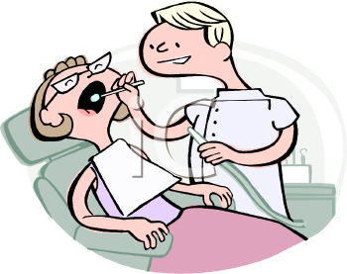
Emergency Dentist
The Dental Service provides dental care for vulnerable people and emergency or urgent dental care to anyone not currently under treatment with a dentist locally. The team consists of dentists, dental therapists, dental hygienists and dental nurses.
Dental Services are provided primarily to residents of Stoke-on-Trent and Staffordshire, although emergency and urgent dental care is available to anyone visiting or working in the area. Special Care patients are often referred into the service via General Dental Practitioners or referred on by a Dentist within the service.
The following services are provided:
- Emergency or Urgent Dental Treatment
- Out of Hours Emergency or Urgent Dental Treatment
- Special Care Dental Treatment
- Routine Dental Care for children
- Epidemiology Surveys
- North Staffordshire Dental Advice Line

Emergency/Urgent Dental Care is provided to anyone with dental pain who is not currently with another dentist locally.
Special Care Dentistry is provided for patients with special needs such as learning disabilities, mental health problems and patients who suffer from dental phobia. This type of dental care typically requires more patient contact time and can involve techniques such as the use of conscious sedation or general anesthesia.
We provide Routine Care for children with specific dental needs which include a General Anesthesia Service for younger children requiring extractions.
An Out of Hours Emergency or urgent dental service is also provided from Hanley Health Centre.
Contact the Dental Advice Line on: Tel 0300 123 0981

The Acute Eye Service
If you have an eye problem not linked with your normal sight test but would like an optician to have a look at your eye condition, this could be things including: Red eyes, conjunctivitis, eye pain, scratches, blurred vision, lumps and bumps, flashes and floaters etc.

If your GP is within the Staffordshire area you can be seen under the Staffordshire Acute Eye System at no charge, as it is covered by NHS funding. Please see below a list of the Opticians involved in the scheme:

Practice | Address | Town | Postcode | Tel Number
Ernest Hanwell Ltd | 8 Tower Square | Tunstall | ST6 5AA | 01782 838710
SW Cotton | 92 Liverpool Rd | Kidsgrove | ST7 4EH | 01782 782385
Stevenson Jones | 6 Friar St | Newcastle-under-Lyme | ST5 2DZ | 01782 619175
James Herd | 59 High Street | Tunstall | ST6 5TA | 01782 837961
B Newbold Ltd | 34 The Iron Market | Newcastle-under-Lyme | ST5 1RP | 01782 617044
Ernest Hanwell Ltd | 11 Glebe Street | Stoke | ST4 1HP | 01782 844105
Specsavers Opticians | 36-38 Market Street | Longton | ST3 1BS | 01782 337830

Integrated Local Care Teams (ILCTs)
The Partnership Trust launched Integrated Local Care Teams to ensure patients living in Staffordshire are better supported to remain healthier and independent at home.
ILCTs comprise of nursing and adult social care teams who support frail, older people and people living with long term conditions such as asthma, diabetes, heart failure and kidney disease, providing care before a crisis occurs.
The teams work with local GPs and specialist nursing and therapy teams to identify those in greatest need of health and social care services. Service user needs are assessed and an individual care plan is created and delivered by a single multi-disciplinary team. Each service user is given a personalised care plan which is assigned a care co-ordinator; this could be their social worker, district nurse or therapist.
This new way of working is improving service delivery and sharing assessment processes, and ensures that patient information does not have to be collected more than once, enabling the provision of co-ordinated, timely care.
Locations:
- North Staffordshire and Stoke-on-Trent
- Hanley/Bentilee - Bentilee Neighbourhood Centre, ST2 0EU
- Hanley/Bucknall - Hanley Health Centre, ST1 2BN
- Longton - Blurton Health Centre, ST3 3BS
- North East - Smallthorne Health Centre, ST6 1SA
- Meir - Meir Primary Care Centre, ST3 6AB
- South West - Hanford Health Centre, ST4 8EX
- Tunstall - Tunstall Primary Care Centre, ST6 6BE
- West - Shelton Primary Care Centre, ST1 4PB
- Madeley/Silverdale - Madeley Surgery/Silverdale Health Centre
- Milehouse/Clayton - Milehouse Primary Care Centre/Kingsbridge Surgery
- Kidsgrove/Audley - Kidsgrove Health Centre/Audley Primary Care Centre
- Chesterton/Porthill - Chesterton Health Centre

Community Nursing
Community nurses have a pivotal role in providing nursing care to patients in the community who may have a diverse range of health conditions. Their primary aim is to support people to stay in their own homes and prevent admission to hospital where possible. Care is also provided in a clinic setting, residential homes and day centres. The service is provided 24 hours per day, 365 days a year.
Their role is complex and varied, but they are trained to assess people’s needs and provide advice and care on how these can be managed in the community setting. Their skills include palliative care, wound management, catheter and continence care and medication management. They provide health education and support people to make healthy choices about their lifestyles. They support those who have recently been discharged from hospital to ensure that they are safe on their return. The community nurses can also refer into other services where additional help is required.
Community nurses work with a range of other professionals, including Social Workers, Occupational Therapists, Physiotherapists, GPs and other specialised nurses as part of a multi-disciplinary team, ensuring quality care and the ongoing assessment, planning, implementation and evaluation of this care.
The adult community nursing service provides well managed and co-ordinated seamless nursing care for people aged 18 years and over. The service forms part of the Trust’s Integrated Local Care Teams (ILCTs) and provides;
- Management of long term conditions
- Palliative and End of Life Care
- Prevention of hospital admissions
- Early supported discharge
- All aspects of wound care
- Health promotion

Please contact your GP Surgery or make an appointment with the Practice Nurse or Doctor if you wish to discuss this further and possibly arrange an ILCT referral.

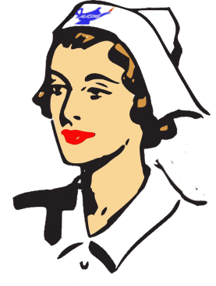

District Nursing
District Nursing is part of Community Nursing, and provides nursing and end of life care to patients in the community.
The client group is patients over the age of sixteen (usually housebound) that require a nursing skill or procedure to be carried out in their own home.
District nurses visit patients in their own homes/residential care homes, assess their healthcare needs, monitor the quality of care they receive, support their family members and are professionally accountable for delivery of care.
As well as providing direct patient care, district nurses also have a teaching role, working with patients to enable them to care for themselves or with family members teaching them how to give care to their relatives.
District Nurses play a vital role in keeping hospital admissions and readmissions to a minimum, and ensuring that patients can return to their own homes as soon as possible.
The services which the Partnership Trust’s District Nursing Team provides include;
- Assist patients to be independent and improve health
- Complex care
- Co-ordinate care and work with other agencies
- Long term conditions
- Palliative and terminal care
- Skilled nursing assessments
- Supported discharge
- Wound care/tissue viability

Locations
- Leek - Moorlands Medical Centre
- Leek - Leek Health Centre
- Biddulph - Biddulph Health Centre
- Silverdale - Silverdale Health Centre
- Knutton/Cross Heath - Milehouse Primary Care Centre
- Kidsgrove - Kidsgrove Health Centre
- Tunstall - Tunstall Primary Care Centre, ST6 6BE
- Shelton - Shelton Primary Care Centre, ST1 4PB
- Hanley/Bentilee - Bentilee Neighbourhood Centre, ST2 0EU

Occupational Therapy
Occupational Therapy is the assessment and treatment of physical and psychiatric conditions using specific, purposeful activity to prevent disability and promote independent function in all aspects of daily life. Services are provided in the patient’s own place of residence or work.
The Occupational Therapy Team help patients to regain skills they may have lost following an illness or disability, for example, helping them to regain skills in washing and dressing, making and eating meals, getting on or off a bed/ toilet.
The service also helps patients with relaxation, anxiety and fatigue management, as well as helping patients who are returning to work and pursuing their leisure activities.
Social care occupational therapists are able to undertake assessments to enable individuals to have adaptations made to their homes, assess for and issue essential equipment required for people to maintain their independence. Specialist equipment is also provided where individuals meet the criteria.
Occupational therapy aims to provide assessment, diagnosis and treatment for people to improve or sustain their skills in activities of daily living (ADLs) in order to live as independently as possible.
The service includes;
- Self-care activities
- Joint protection
- Prevention of further deterioration of health conditions
- Palliative and end of life care
- Condition management (pain, fatigue, etc)
- Health promotion strategies
- Adaptation of the environment
- Equipment provision (criteria-led)

If you feel that you would like further help and advice or would like to be assessed for any of the above, please contact the surgery and make an appointment with the GP or Practice Nurse as this service will require a referral letter.

Location

North Staffordshire and Stoke on Trent Occupational Health
Community Therapy Referral Centre
Shelton Primary Care Centre
Norfolk Street, Shelton
Stoke on Trent, ST1 4PB
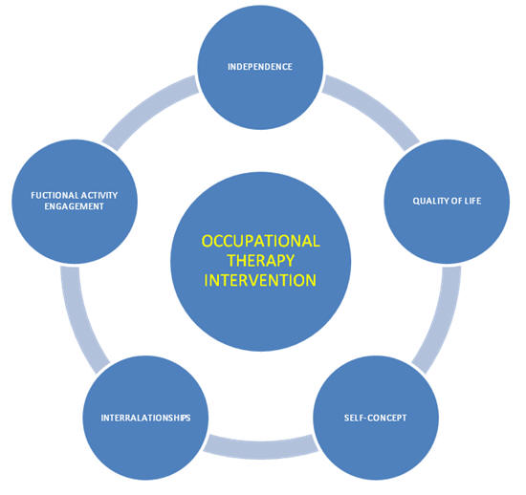

Wheelchair & Equipment Service
The wheelchair services provide assessment and provision of wheelchair and postural seating supports for people who have long term or permanent/progressive disabilities which impact their mobility.
The services include;
- Expert and specialized mobility and postural control equipment
- Clinically-based assessments
- Prescriptions for manual and powered wheelchairs, specialized seating and pressure relief cushions
- All necessary accessories e.g. trays, headrests, elevating leg rests
- All modifications as deemed necessary to equipment
- Maintenance and repair package to all clients
- Voucher scheme.

Where to find us

North Staffordshire
Northern Division Wheelchair Service
Haywood Hospital
High Lane, Burslem
Stoke-on-Trent, ST6 7AG

The British Red Cross also provide short-term loans of mobility aids to people in need, including wheelchairs. We provide short-term loans of wheelchairs and other equipment. These are designed to help you get around and improve your comfort. The types of mobility aids you can borrow include:

Wheelchairs Commodes
Bedpans Urinals
Crutches Backrests
Bathseat Walking Stick and Frames

Contact: The British Red Cross, Tel: 0808 196 3651

Help with Financial Issues
Age UK
Before you make any decisions about your money, it’s a good idea to look at your present circumstances carefully. Once you have all the facts and figures about your money, the next stage is to balance your budget, so your outgoings match your income. If you still don’t have enough money coming in, now is a good time to review your spending. Are there any non-essential items that you could reduce or cut out? Be realistic and DON’T cut down on essential things like food and heating. Instead, assess whether you are spending more that you need to on things like energy bills. You may be able to save some money by changing your energy supplier. Check which energy suppliers offer special discounts, such as dual-fuel discounts, or other services, such as cheaper telephone charges. Energy suppliers have social tariffs available on request that may offer good savings. Ask your current supplier about their best offer before thinking about switching.
Many retired older people do not claim all the benefits that they’re entitled to. Some benefits including Pension Credit, Housing Benefit and Council Tax Benefit, are means-tested. Whether you qualify and how much you get depends on your income and savings. If you have difficulty understanding the information contained within the application forms, AGE UK can help and assist you in completing the application form for things like:
Attendance Allowance (AA) is a benefit paid to people aged 65 or over who have personal care needs or who need supervision to keep them safe. Personal care includes help with activities such as washing, dressing, going to the toilet or getting around the house. Attendance Allowance is not means-tested, so your savings and income to not affect your eligibility.
Disability Living Allowance (DLA) is a similar benefit for people who are under 65. It also includes a mobility component for people who have great difficulty in walking or can’t walk at all. This benefit has been replaced with a Personal Independence Payment (PIP).
For more information please contact: Age UK North Staffordshire on 01785 788499

Citizens Advice Bureau
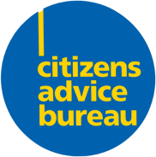
If you need advice on any issue that is causing you a problem contact the Citizens Advice Bureau. The subjects they specialise in are problems with social security benefits, personal debt, or housing; employment disputes and immigration issues. They also offer specialist help to the victims of crime. They make their services as accessible as they can to the many communities within the local area. All of their premises have been especially designed to be as accessible as possible to people with physical disabilities, mobility or other sensory impairments. They offer face to face advice in four main locations across the area:

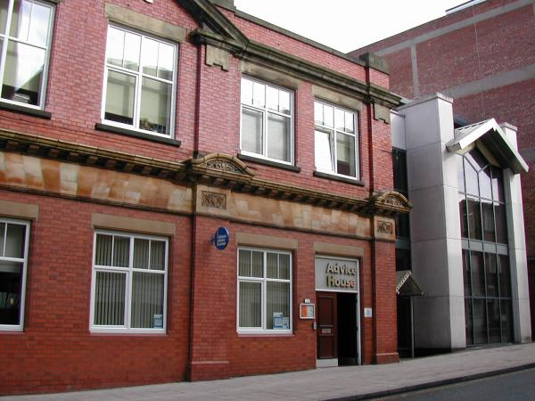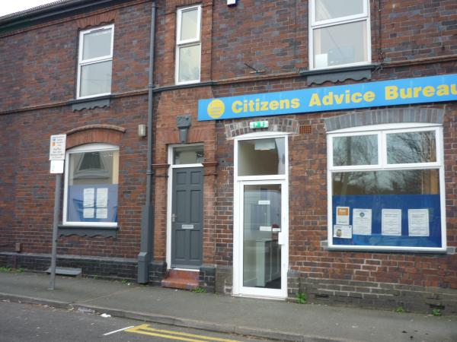
Hanley Newcastle under Lyme
Advice House 25-27 Well Street
Cheapside Newcastle under Lyme
Hanley Staffs
Stoke-on-Trent. Staffs ST1 1HL ST5 1BP

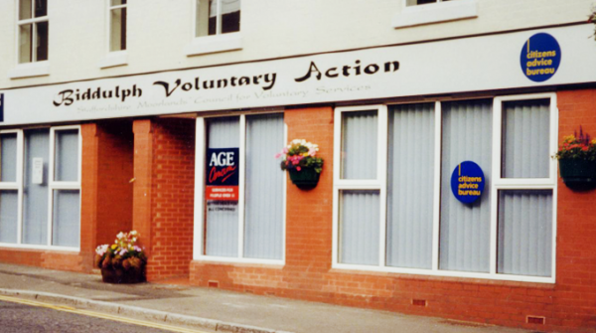
Biddulph Kidsgrove
10 Tunstall Road Town Hall. Liverpool Road
Biddulph Kidsgrove SOT
Staffs. ST8 6HH ST7 4EH

To speak to the Citizens advice bureau please contact
Reception (admin NOT advice) – 01782 201234
Local advice line - 0808 278 78 76

Conclusion
We hope that all of the information contained within this booklet will be of beneficial help to you. If you do require any further help or assistance, please contact a member of staff at Lucie Wedgwood Surgery.
Thank You for reading.

