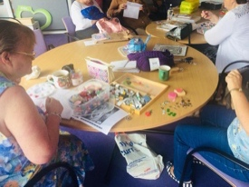****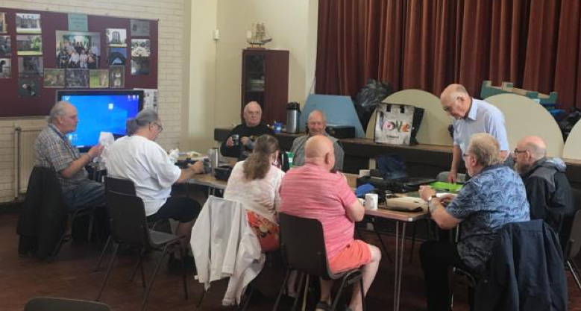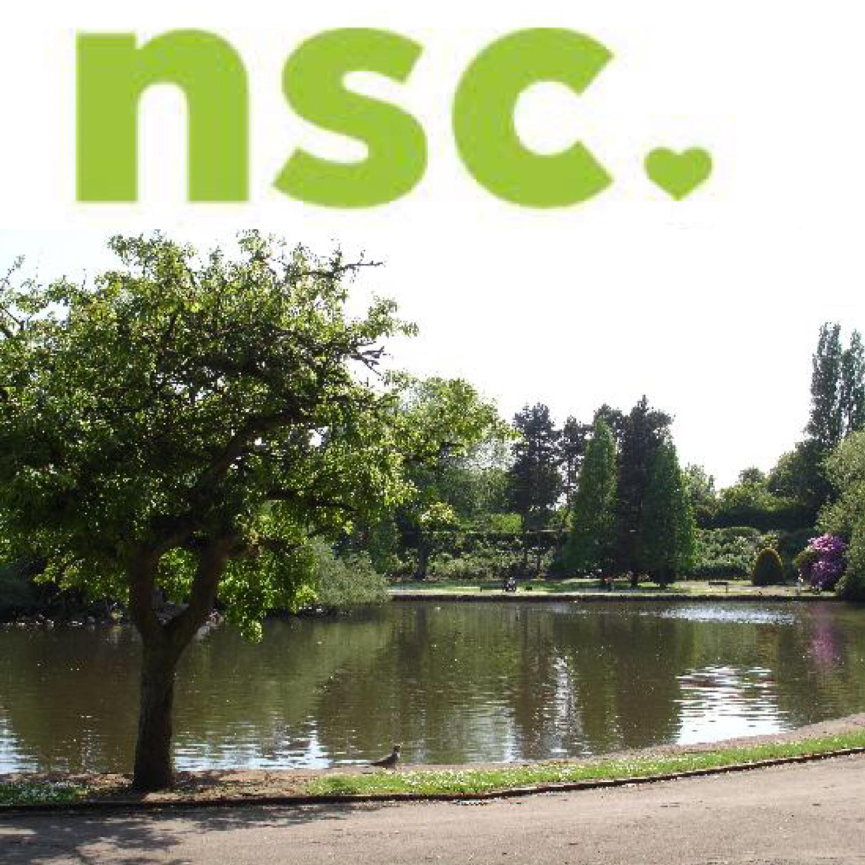****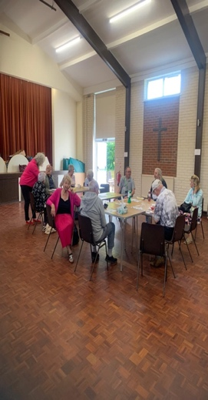

**Wednesday - 8th/22nd**

**Arts n Craft Group**

**Temple Street Methodist Church**

**10.00 am – 12 noon**

**If you would like further details or would like to talk to someone here at North Staffs Carers about your caring role and what support, we can offer.**

**Please call us on 01782 793100**

**Or Alternatively Drop in at our Offices**

**Trent House,**

**234 Victoria Road,**

**Fenton, Stoke-on-Trent,**

**ST4 2LW**

**No appointment necessary**

**Friday 24th**

**Legal Clinic**

**At Trent House**

**Appointment Only**

**Wednesday 22nd**

**Young Adult Carers**

**18 – 25 years**

**Takeaway Evening**

**6.00 – 7.30 pm**

**Every Wednesday**

**Photography Club**

**Temple Street Methodist**

**Church**

**10.00 am – 12 noon**

**Wellbeing Wander**

**Longton Park - 2nd September**

**(Meet at Trentham Road Entrance)**

**Tunstall Park - 9th September**

**(Meet at Floral Hall)**

**Westport Lake - 16th September**

**(Meet at Visitors Centre)**

**Fenton Park - 23rd September**

**(Meet at Victoria Road Entrance)**

**Hanley Park - 30th September**

**(Meet at the Bandstand)**

**Monday 6th**

**Drop in Session at Temple Street Methodist Church**

**Meet with a member of our staff**

**10.00 am – 11.30 am**

**What’s On September 2021**

**Monday 20th/27th**

**Therapies for Carers**

**At**

**Trent House**

**Appointment Only**

**Every Monday**

**Carer Support Group**

**Temple Street**

**Methodist Church**

**10.00 am – 12 noon**